**EXPERIMENT 10**

**Aim:**

4×4 Keypad with 16x2LCD I2C interface controlled by Arduino UNO.

**Components Required:**

1. Arduino UNO
2. 4×4 Keypad
3. 16x2LCD I2C interface
4. Jump wires
5. USB cable

**Theory:**

1. Keypad Matrix Scanning:

A 4x4 keypad comprises 16 individual key switches arranged in a 4-row, 4-column matrix.

To detect which key is pressed, we cannot directly connect all 16 keys to the Arduino's digital pins. Instead, we employ a technique called "matrix scanning."

We connect the four rows of the keypad to separate digital pins on the Arduino (e.g., pins 2-5).

Similarly, we connect the four columns to another set of digital pins (e.g., pins 6-9) through resistors (typically 10kΩ) to ground. These resistors prevent "ghosting" (registering unintended key presses due to stray electrical signals).

1. Scanning Process:

The Arduino operates by:

Setting all column pins to LOW (output mode).

Setting one row pin to HIGH (input mode).

Checking the state (LOW or HIGH) of each pin in the remaining rows.

If a row pin reads LOW, it indicates a closed circuit (key press) at the intersection of the selected row and column. Repeating this process for all rows, one by one.

Based on the row and column that triggered a LOW reading, we can identify the corresponding key pressed using a pre-defined key mapping table (2D character array).

Once the key is identified, the column pin is set back to HIGH for proper scanning in subsequent loops.

1. 16x2 LCD Display:

The 16x2 LCD (Liquid Crystal Display) is a common display module with 16 characters per row and 2 rows.

To control this display, we can use various libraries or protocols. In this experiment, we'll leverage the I2C communication protocol for efficient data transmission between the Arduino and the LCD.

The I2C protocol only requires two wires (SCL - Serial Clock and SDA - Serial Data) for communication, reducing the number of connections needed compared to traditional methods.

An I2C-compatible LCD module allows us to send data (characters, commands) to the display using the I2C library in the Arduino code.

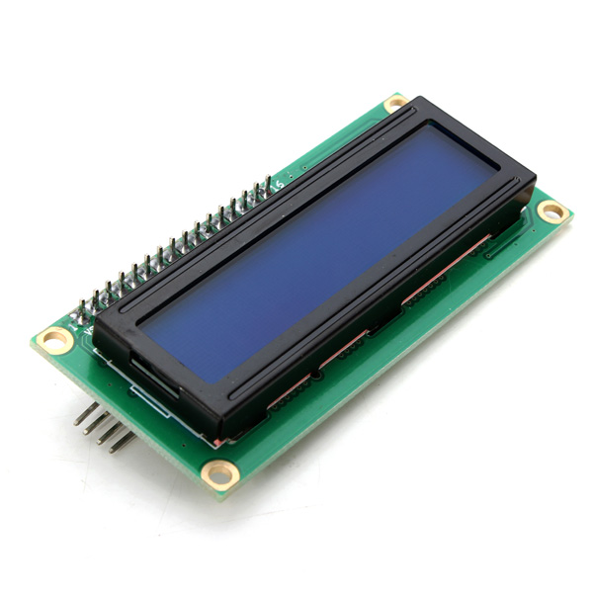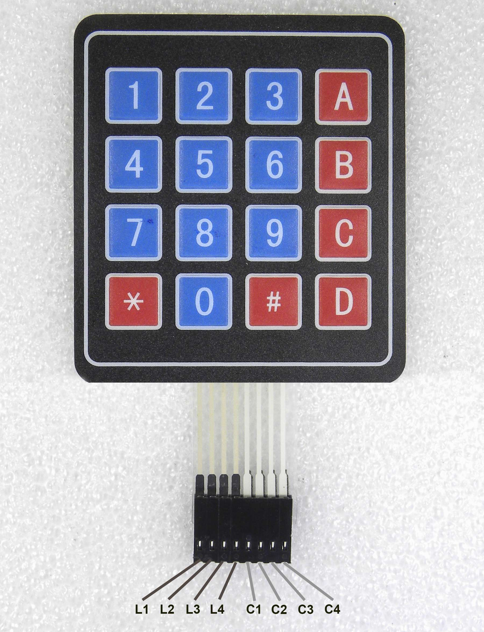

**Sketch Code:**

#include <LiquidCrystal_I2C.h>

#include <Keypad.h>

const int ROW_NUM = 4; //four rows

const int COLUMN_NUM = 4; //four columns

LiquidCrystal_I2C lcd(0x27, 20, 4);

char keys[ROW_NUM][COLUMN_NUM] = {

{'1','2','3', 'A'},

{'4','5','6', 'B'},

{'7','8','9', 'C'},

{'*','0','#', 'D'}

};

byte pin_rows[ROW_NUM] = {9, 8, 7, 6}; //connect to the row pinouts of the keypad

byte pin_column[COLUMN_NUM] = {5, 4, 3, 2}; //connect to the column pinouts of the keypad

Keypad keypad = Keypad( makeKeymap(keys), pin_rows, pin_column, ROW_NUM, COLUMN_NUM );

void setup(){

lcd.init(); // display initialization

lcd.clear();

lcd.backlight(); // activate the backlight

lcd.setCursor(0, 0); // stand in the front line

}

void loop(){

char key = keypad.getKey();

if(key) //press a key on the 4x4 matrix keypad

{

lcd.print(key); // Display the entered character on the LCD display

delay(100);

}

}

**Result:**

The experiment successfully demonstrated the interfacing of a 4x4 keypad with a 16x2 LCD via I2C communication on an Arduino UNO. The implemented code effectively scanned the keypad matrix, identified pressed keys, and displayed them on the LCD.

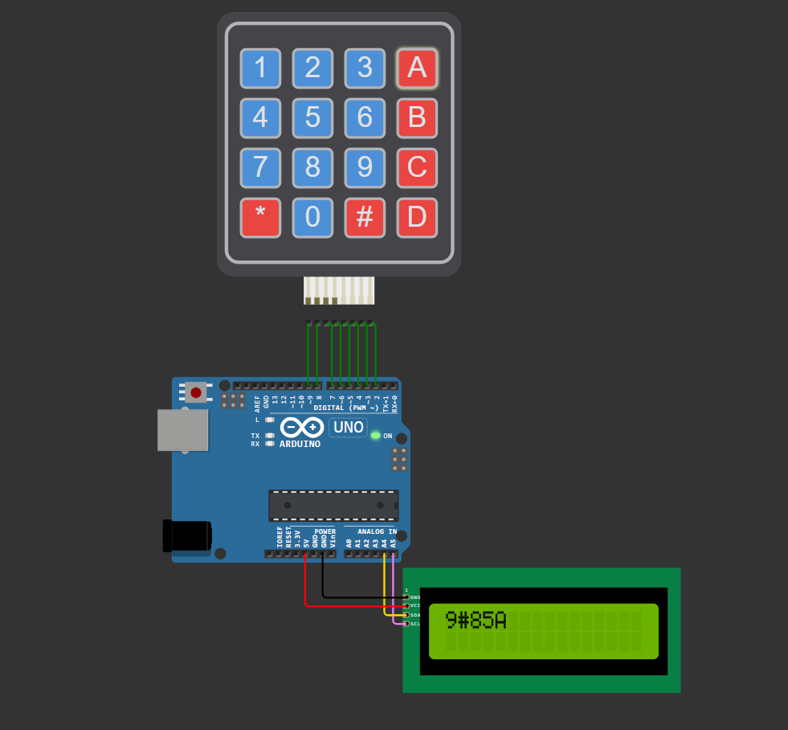

Rajdeep Mandal (22052746)

Vikash Shaw (22052694)

Suvarna Vats(22052517)